**Unit VI: Electronic Data Interchange (EDI)**

Electronic Data Interchange (EDI) is a standardized method used for transferring data between different organizations electronically. It replaces traditional paper-based documents such as purchase orders or invoices with electronic formats, facilitating faster, more accurate, and cost-efficient communication.

Here's a table that highlights the differences between **Electronic Data Interchange (EDI)** and **email**:

| **Aspect** | **Electronic Data Interchange (EDI)** | **Email** |
| --- | --- | --- |
| **Purpose** | Automated exchange of structured business documents | General-purpose communication tool |
| **Format** | Strict, standardized formats | No fixed format (plain text, rich text, attachments) |
| **Automation** | Fully automated with no manual intervention | Often requires manual interaction to send/receive |
| **Use Case** | Primarily used for B2B transactions (invoices, orders, etc.) | Can be used for any form of communication |
| **Data Processing** | Automatically processed by software systems | Often requires human interpretation and action |
| **Integration** | Integrated into business systems (ERP, SCM, etc.) | Not directly integrated; typically used manually |
| **Security & Compliance** | High security and compliance (e.g., encryption, authentication) | Varies depending on email service and configuration |
| **Error Handling** | Errors are minimized due to structured data and automation | Prone to human errors, such as wrong attachments or miscommunication |
| **Speed** | Near-instantaneous data exchange between systems | Depends on user action and email servers |

**Concepts of EDI**

1. **Definition of EDI**:  
   EDI refers to the structured transmission of data between organizations by electronic means. It is primarily used for business transactions and replaces traditional paper documents like invoices and purchase orders with electronic versions.
2. **Key Characteristics of EDI**:
   * **Standardization**: EDI uses standard formats like ANSI X12, EDIFACT, and XML to ensure all parties involved can read and interpret the data.
   * **Automation**: EDI automates the exchange of data, eliminating the need for manual intervention in routine business transactions.
   * **Data Security**: The communication through EDI is secure and ensures that sensitive business information is protected.
   * **Faster Transaction Speed**: Compared to traditional methods, EDI allows near-instantaneous transmission of documents, improving efficiency.
3. **Components of EDI**:
   * **Sender and Receiver**: The two key parties that are exchanging data electronically.
   * **EDI Standards**: These include formats such as ANSI (used in North America), EDIFACT (used internationally), and TRADACOMS (used in retail sectors).
   * **EDI Software**: This software translates and formats data from internal systems (like ERP or inventory systems) into the appropriate EDI standard.
   * **EDI Network**: Also known as Value Added Networks (VANs), which securely transmit EDI messages between trading partners.

**Applications of EDI**

1. **Supply Chain Management**:
   * EDI is widely used in supply chains to facilitate the automated exchange of order-related documents like purchase orders, shipping notices, and invoices between trading partners.
2. **Retail**:
   * Retail companies use EDI to communicate with suppliers for order processing, stock management, and inventory updates.
   * Supermarkets and large retail chains often use EDI to streamline their logistics and inventory management, reducing manual errors and improving time efficiency.
3. **Healthcare**:
   * EDI is used in the healthcare sector to transfer patient records, insurance claims, and billing data between healthcare providers and insurance companies.
   * HIPAA (Health Insurance Portability and Accountability Act) compliance in the U.S. mandates the use of EDI for claims processing.
4. **Automotive Industry**:
   * Car manufacturers use EDI to communicate with parts suppliers, allowing them to coordinate supply schedules, shipping details, and invoices. The Just-in-Time (JIT) inventory system is a key beneficiary of EDI in the automotive industry.
5. **Financial Services**:
   * EDI is used in banking for processing payments, loan applications, and inter-bank fund transfers.
   * It facilitates secure and standardized communication for international banking transactions and cross-border payments.
6. **Government**:
   * EDI is used by governments for tax reporting, customs documentation, and electronic procurement processes.

**Advantages of EDI**

1. **Cost Efficiency**:
   * EDI reduces the cost associated with paper documents, printing, and postal services. It also reduces labor costs as it eliminates the need for manual data entry.
2. **Faster Transactions**:
   * Since the exchange of information is electronic and standardized, transactions are processed quickly, often in real-time.
3. **Improved Accuracy**:
   * EDI minimizes human errors that are common in manual processes. Automatic data transmission ensures that the information exchanged is accurate and complete.
4. **Better Business Relationships**:
   * The use of EDI leads to improved collaboration and coordination between businesses, as it enhances visibility into processes such as order status and shipment tracking.
5. **Scalability**:
   * EDI allows businesses to grow and scale by easily adding more partners and increasing transaction volumes without additional manual processes.
6. **Environmental Benefits**:
   * As EDI reduces the need for paper documents, it contributes to sustainability by reducing paper usage and promoting a paperless office environment.

**Disadvantages of EDI**

1. **High Initial Setup Costs**:
   * Setting up an EDI system requires significant initial investment in hardware, software, and employee training. Small businesses may find it costly to adopt.
2. **Complexity**:
   * The setup of EDI involves complex protocols and standards that require expertise. Customizing EDI systems to integrate with existing systems can be difficult.
3. **Standardization Issues**:
   * While EDI uses standard formats, different industries might adopt different standards (e.g., ANSI vs. EDIFACT), leading to compatibility issues.
4. **Lack of Flexibility**:
   * Once implemented, EDI systems are rigid and can be difficult to modify or update according to changing business needs or processes.
5. **Dependency on Partners**:
   * Businesses must ensure that all their trading partners are also using EDI. If a partner is not EDI-enabled, this can create a bottleneck in the automated process.
6. **Security Risks**:
   * While EDI enhances security, there are still risks of cyber-attacks or data breaches if the network is not secured properly.

**EDI Models**

EDI models refer to different approaches or architectures used for implementing and exchanging electronic data between businesses.

1. **Direct EDI (Point-to-Point)**:
   * In this model, a direct connection is established between two trading partners without an intermediary. Data is exchanged directly over a secure, private network. While this model offers high security, it can be expensive to maintain.

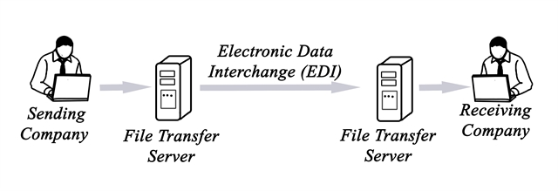

1. **EDI via Value-Added Networks (VAN)**:
   * VANs act as intermediaries that manage the transfer of EDI data between trading partners. These networks provide additional services like data security, error checking, and data storage. VANs are costlier but more manageable, especially for smaller businesses.

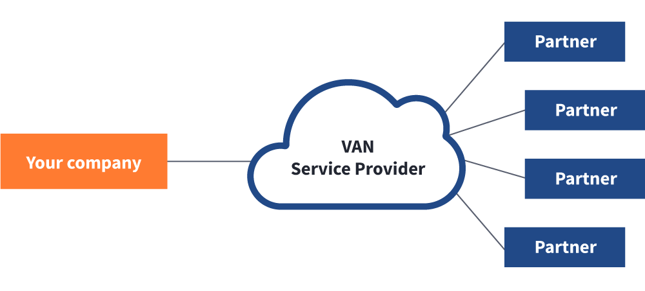

1. **Web-Based EDI**:
   * This is a cost-effective method that uses internet-based platforms for exchanging EDI messages. It’s popular among smaller businesses because it doesn’t require a lot of infrastructure investment.

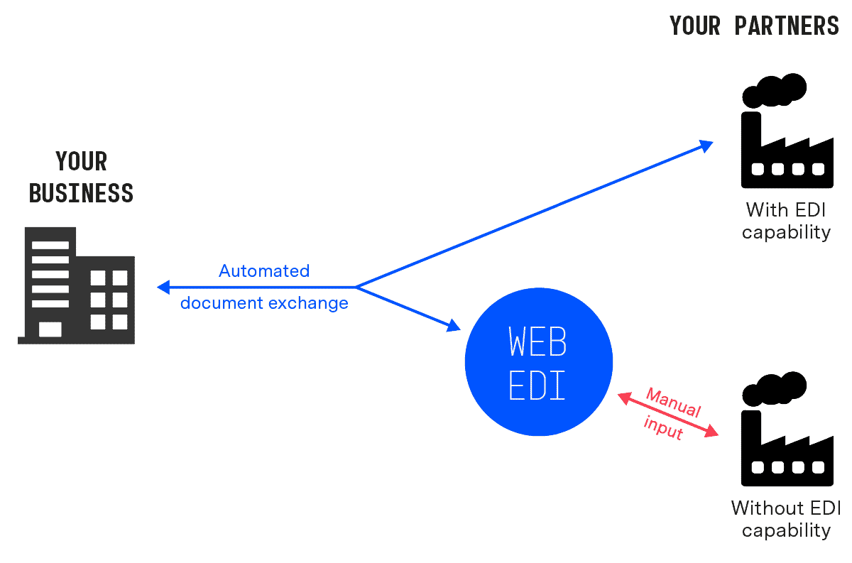

1. **EDI Outsourcing**:
   * In this model, businesses outsource their EDI operations to a third-party provider. This helps reduce the complexity of maintaining an in-house EDI system.

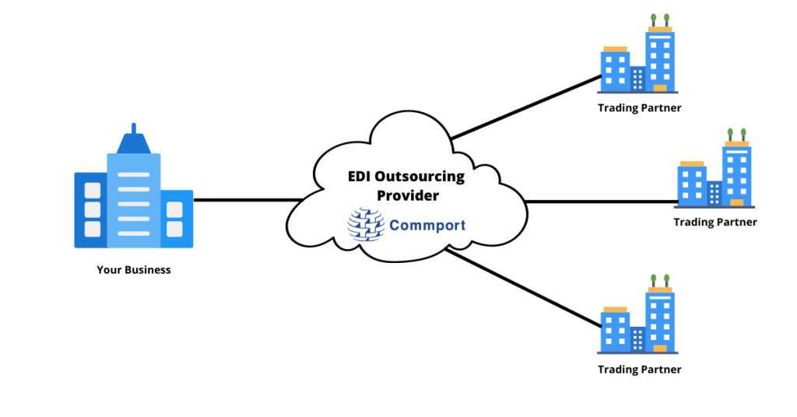

1. **Hybrid EDI**:
   * This model combines two or more EDI methods, like direct EDI for key partners and web-based EDI for smaller partners. It allows businesses to be flexible and cost-efficient while expanding their EDI capabilities.